Abstract submission for TAC 2015

A.N. Other¹, R.T. Polo²
¹Department of Pharmacy, University of Bath, Bath, UK.
²Pharma R&D, City, Country.

INTRODUCTION

Please include the goal of the research in this section. This template has been written to show the correct typeset for your abstract and also includes additional guidance.

Materials and Methods

All papers must be submitted electronically in Word .doc format. Prepare your paper using A4 page size of 21cm × 29.7 cm. Please consider:-
1) Font size and typefaces: Use 14 point bold, capital letters for the title in Times New Roman, 12 point Times New Roman (normal) characters for author names and 10 point Times New Roman characters for the body text and affiliations.
2) Formatting: In formatting your page, set top and bottom margins to 2.54 cm. Left margin should be set to 1.7cm and right margin set at 1.5cm.

RESULTS AND Discussion

Graphics should be in TIFF or PNG format, 600 dpi for graphics, charts, drawings or tables and 200 dpi for photos and gray scale images. Image resolution can be compressed by right clicking on the image, clicking the “Format Picture” menu, followed by the “Picture” tab and clicking on the compress button. Choose the Print check box to alter the resolution to 200dpi.

Figure captions should be centred and placed below the figures; table names and table captions should be above the tables. Captions should be 8 point Times New Roman (normal). Avoid placing figures and tables before their first mention in the text.

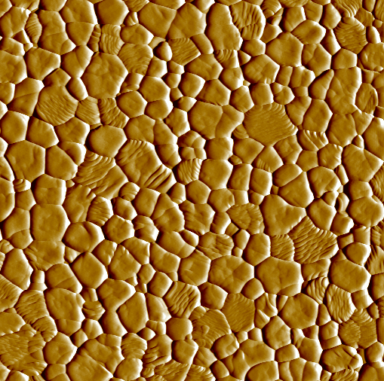

Fig. 1. Scanning probe microscopy image of annealed calcium phosphate.

CONCLUSIONS

References should be cited consecutively in square brackets [1]. The sentence punctuation follows the bracket e.g. [2]. Please note that the reference examples at the end of this document are in the preferred referencing style. Give all authors’ names; do not use “et al.” unless there are six authors or more. Papers that have not been published, even if they have been submitted for publication, should be cited as “unpublished” [3]. Papers that have been accepted for publication should be cited as “in press” [4].

ACKNOWLEDGMENTS

REFERENCES

[1] R.T. Polo, “Paper/Chapter title in Book” in Pharmaceutical Sciences, R.P Thomas and P.R Davies, Angel Falls, London, Publisher, 1993, ch. 3, pp. 61–74.
[2] A.N. Other and R.T Polo, “Engineered particles for inhalation” Int. J. Pharm., 49 (2002) 1204 – 1210.
[3] A.N. Other, R.T. Polo and T.P Miller, “Title of paper if known,” unpublished.
[4] T.O. Miller, “A novel in-vivo approach for the quantitative assessment of respirable dose” J. Pharm. Sci., in press.

